ILMA CMS
Scheduling Messages — Module Plan
One scheduling engine reused across Noticeboard, Chat and Alerts — the same pattern as Scheduled Payments

1. Purpose
This document scopes a “Schedule for later” capability for in-app messages — Noticeboard posts, Chat announcements, and Alert broadcasts. It reuses the same scheduling pattern as Scheduled Payments/Payroll: one generic engine, added as a property of the existing compose screens rather than a new standalone module.

2. Where It Fits
No new page in the sidebar. Wherever someone composes a message today — Noticeboard, Chat, or a WhatsApp/SMS/Email alert screen — add one toggle: Send now vs. Schedule for later, with a date-time picker and an optional recurrence (e.g. “every Monday 8am” for a standing reminder).

3. Data Model
ScheduledMessage carries the compose-time content, audience and timing; MessageDispatch is created once per recipient per channel at send time, so delivery status and cost are tracked independently of the schedule itself.
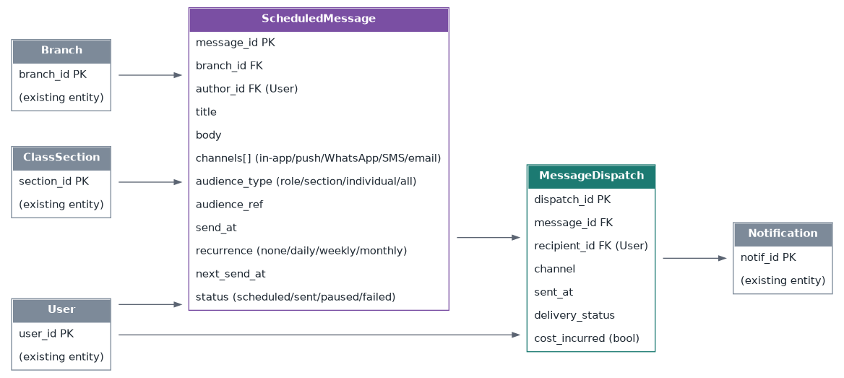
Figure 1 — ScheduledMessage generates a MessageDispatch row per recipient per channel, feeding the existing Notification entity.

4. Message Lifecycle
The same background job that checks for due scheduled payments also checks for due scheduled messages — one shared scheduler, not a second one built specifically for messaging.
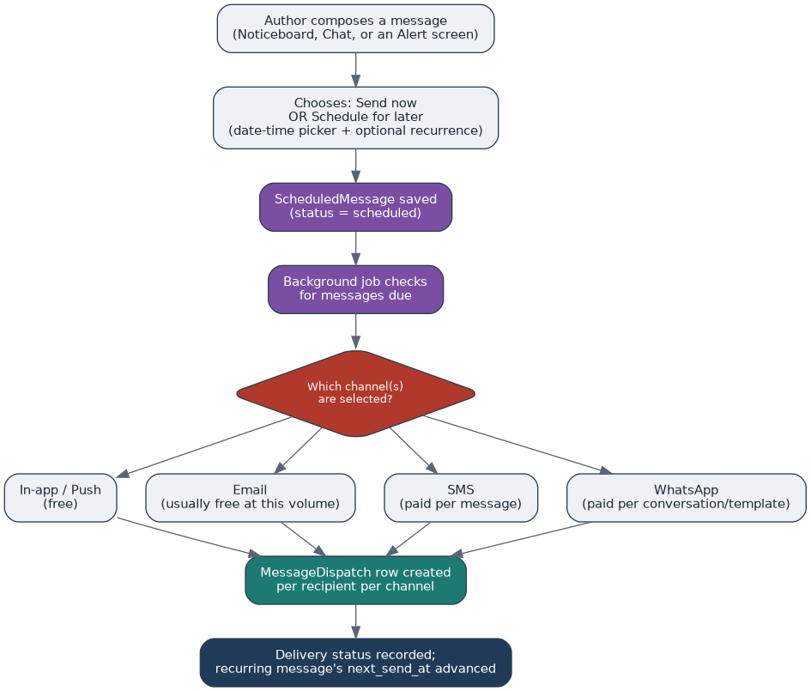
Figure 2 — Scheduled message lifecycle. Channel choice is the only point where cost enters the picture.

5. Cost by Channel
Scheduling itself is free regardless of channel — it's the delivery channel chosen at send time that carries a cost:
Channel | Cost
In-app / push notification | Free
Email | Usually free or near-free at this volume
SMS | Paid per message
WhatsApp | Paid per conversation/template (Meta's pricing)
Recommendation: default scheduled reminders (fee due, exam date, homework) to free in-app/push, and reserve WhatsApp for the same escalation cases already in the automation registry (e.g. 3 consecutive absences) — not for routine scheduled notices.

6. Recurrence & Standing Reminders
- A ScheduledMessage with recurrence set (daily/weekly/monthly) behaves like a template: each run creates its own MessageDispatch batch, and next_send_at advances — identical mechanics to recurring payroll.
- Recurring messages can be paused (status = paused) without deleting them, e.g. pausing a weekly reminder during school holidays.
- A recurring message's audience is re-evaluated at each send, not fixed at creation — so “every Monday, remind Section 9-A's parents” automatically includes any student added to the section after the message was first scheduled.

7. Open Questions
- Should a single ScheduledMessage support multiple channels at once (e.g. in-app + WhatsApp together), or one channel per scheduled message for simpler cost tracking?
- Who can schedule messages — any Teacher, or only Admin/Coordinator for broadcasts beyond a single class?
- Should there be a per-institute monthly cap on paid-channel (SMS/WhatsApp) scheduled sends, to prevent accidental overspend from a recurring message left running?
- Does a scheduled message need an edit/cancel window before send_at, and if so, how close to send time should editing be locked?

